**The Endosymbiotic Theory of Eukaryote Evolution**

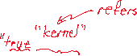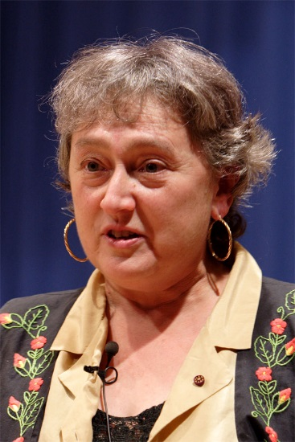

By Jpedreira - Self-published work by Jpedreira, CC BY-SA 2.5, https://commons.wikimedia.org/w/index.php?curid=407368

Dr. Lynn Margulis

1938-2011

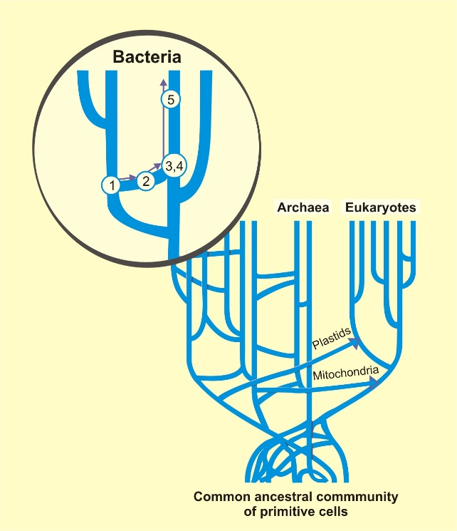

By Dr. Smets and perhaps others - Barth F. Smets, Ph.D., with permission, Attribution, https://commons.wikimedia.org/w/index.php?curid=5720886

Tree of life showing vertical and horizontal gene transfers

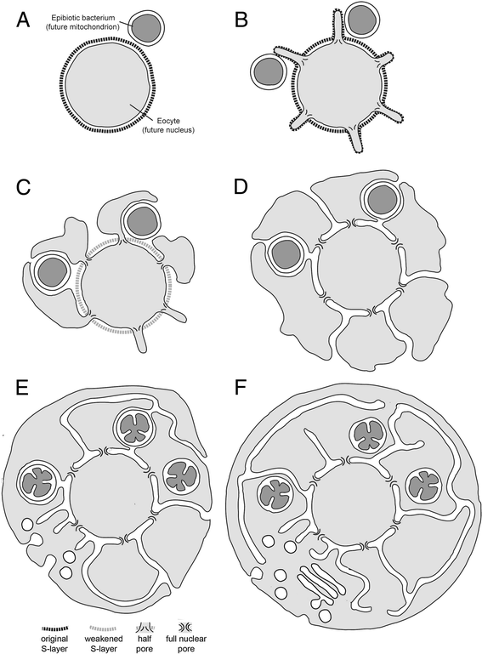

*BMC Biology* 2014 **12**:76

<https://doi.org/10.1186/s12915-014-0076-2>

©  Baum and Baum; licensee BioMed Central Ltd. 2014

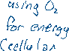

Hiroyuki Imachi and his team devised a culture protocol that allowed them to grow members of the Asgard archaen for the first time. Imachi calls the organism *Prometheoarchaeum syntrophicum*. His team were able to photograph (above) and study its behaviour. It is a possible ancestor of the archaen that “swallowed” a bacterium leading to the evolution of the Eukaryota. 

Article accessed 2019/10/2.

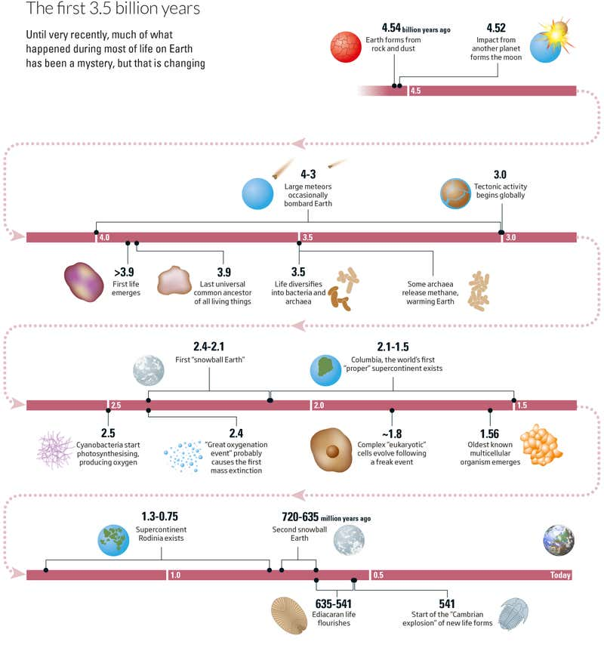

“In the beginning: the full story of life on Earth can finally be told,” by Michael Marshall, *New Scientist*, issue 3212. Published 12 January 19, amended 6 February 2019.