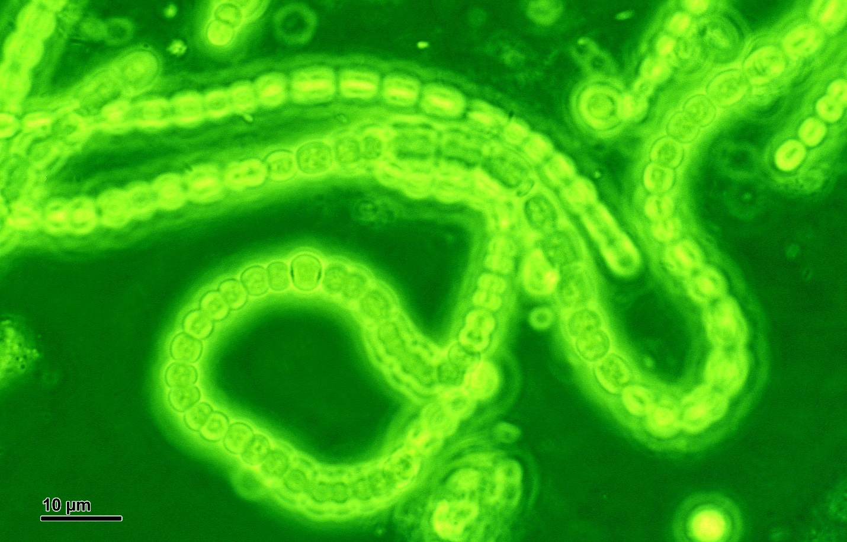
The Great Oxygenation Event

Cyanobacteria: Responsible for the buildup of Oxygen in the Earth’s atmosphere.

By Doc. RNDr. Josef Reischig, CSc. - Author's archive, CC BY-SA 3.0, https://commons.wikimedia.org/w/index.php?curid=31550579
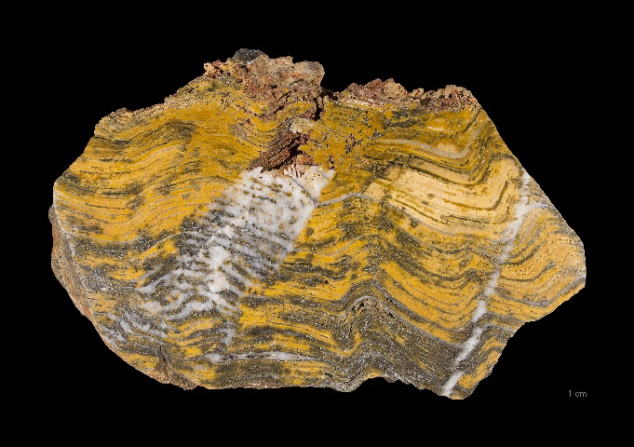
https://commons.wikimedia.org/wiki/File:Stromatolithe_Pal%C3%A9oarch%C3%A9en_-_MNHT.PAL.2009.10.1.jpg#/media/File:Stromatolithe_Pal%C3%A9oarch%C3%A9en_-_MNHT.PAL.2009.10.1.jpg
Stromatolites are formed over the years by mats (1-10 mm in thickness) of cynobacteria, among others, found in shallow, mainly marine waters. The microorganisms precipitate mineral particles, which makes the mat thicken, but only the upper part survives. Most stromatolites display characteristically layered structures. Only the layers are visible to the naked eye. Paleoarchean from -3 600 à -3 200 Ma (million years ago). Locality: Western Australia

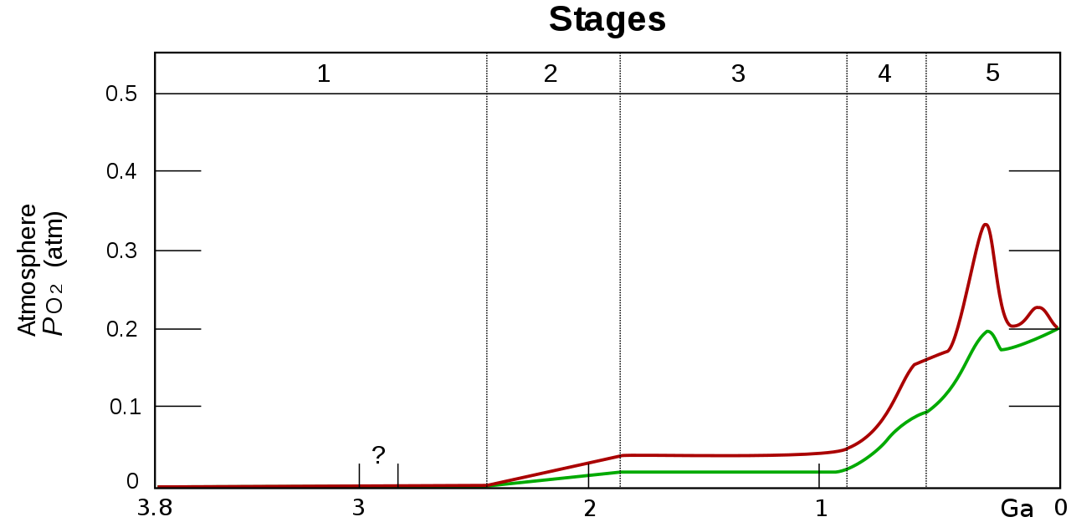
Estimated evolution of atmospheric oxygen partial pressure (PO₂). The upper red and lower green lines represent the range of the estimates of PO₂. The stages are:
Stage 1 (3.85 – 2.45 Gyr ago (Ga)) Practically no O₂ in the atmosphere. The Oceans were also largely anoxic with the possible exception of O₂ gases in the shallow areas.
Stage 2 (2.45 – 1.85 Ga) O₂ produced, and rose to values of 0.02 to 0.04 atm, but absorbed by the oceans and seabed rocks.
Stage 3 (1.85 – 0.85 Ga) O₂ starts to gas out of the oceans, but is absorbed by land surfaces and formation of ozone layer. There was no significant change in O₂ levels.
Stages 4 (0.85 – 0.54 Ga) and 5 (0.54 Ga – present) O₂ sinks filled, the gas accumulates.
By Oxygenation-atm.svg: Heinrich D. Hollandderivative work: Loudubewe (talk) - Oxygenation-atm.svg, CC BY-SA 3.0, https://commons.wikimedia.org/w/index.php?curid=12776502

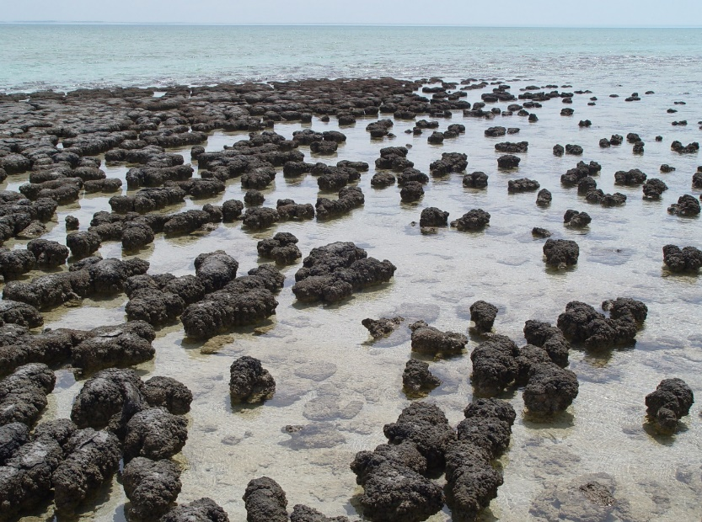

By Paul Harrison - Photograph taken by Paul Harrison (Reading, UK) using a Sony CyberShot DSC-H1 digital camera., CC BY-SA 3.0, https://commons.wikimedia.org/w/index.php?curid=714512

Stromatolites growing in Hamelin Pool Marine Nature Reserve, Shark Bay in Western Australia..

