Quorum Sensing and Biofilms

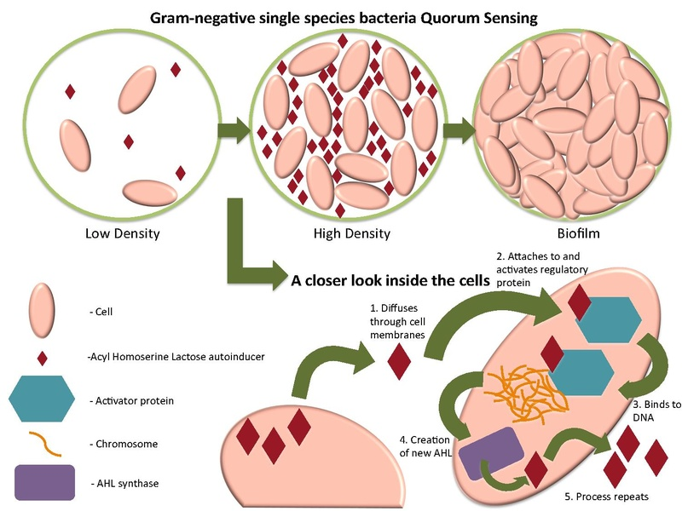
From https://en.wikipedia.org/wiki/File:Quorum_sensing_of_Gram_Negative_cell.pdf

Five stages of biofilm development: (1) Initial attachment, (2) Irreversible attachment, (3) Maturation I, (4) Maturation II, and (5) Dispersion. Each stage of development in the diagram is paired with a photomicrograph of a developing P. aeruginosabiofilm. All photomicrographs are shown to the same scale.
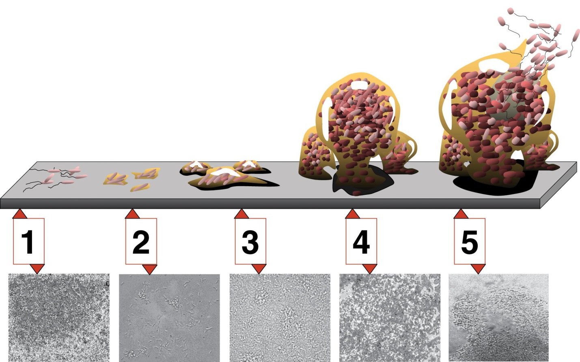
By D. Davis - From: Looking for Chinks in the Armor of Bacterial Biofilms Monroe D PLoS Biology Vol. 5; No. 11; e307 doi:10.1371/journal.pbio.0050307 http://biology.plosjournals.org/perlserv/?request=slideshow&type=figure&doi=10.1371/journal.pbio.0050307&id=89595; CC BY 2.5 https://commons.wikimedia.org/w/index.php?curid=3364284

