**Introduction to Bacteria**

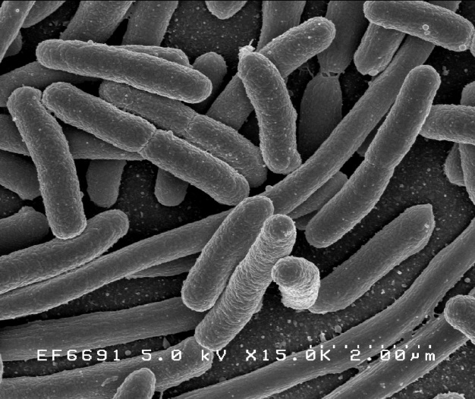

By Credit: Rocky Mountain Laboratories, NIAID, NIH - NIAID: These high-resolution (300 dpi) images may be downloaded directly from this site. All the images, except specified ones from the World Health Organization (WHO), are in the public domain. For the public domain images, there is no copyright, no permission required, and no charge for their use., Public Domain, https://commons.wikimedia.org/w/index.php?curid=104228

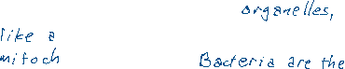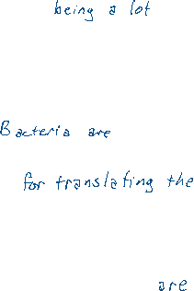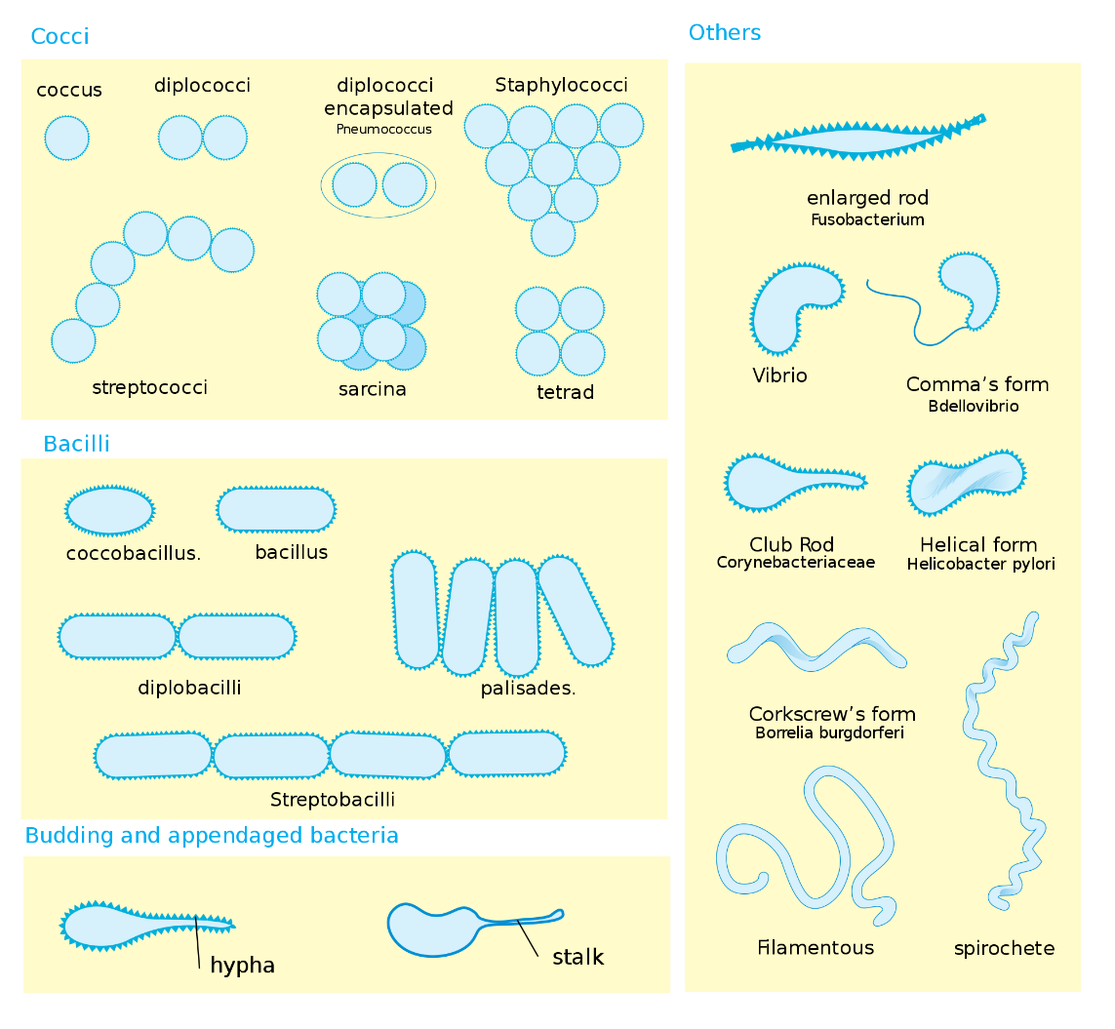

By Mariana Ruiz LadyofHats - the image i did myself using adobe ilustrator, using the information found on[1], [2] ,[3] ,[4], [5] ,[6], [7]and the book "medizinische mikrobiologie" from ernst wiesmann ED. Thieme (1986), Public Domain, https://commons.wikimedia.org/w/index.php?curid=738916



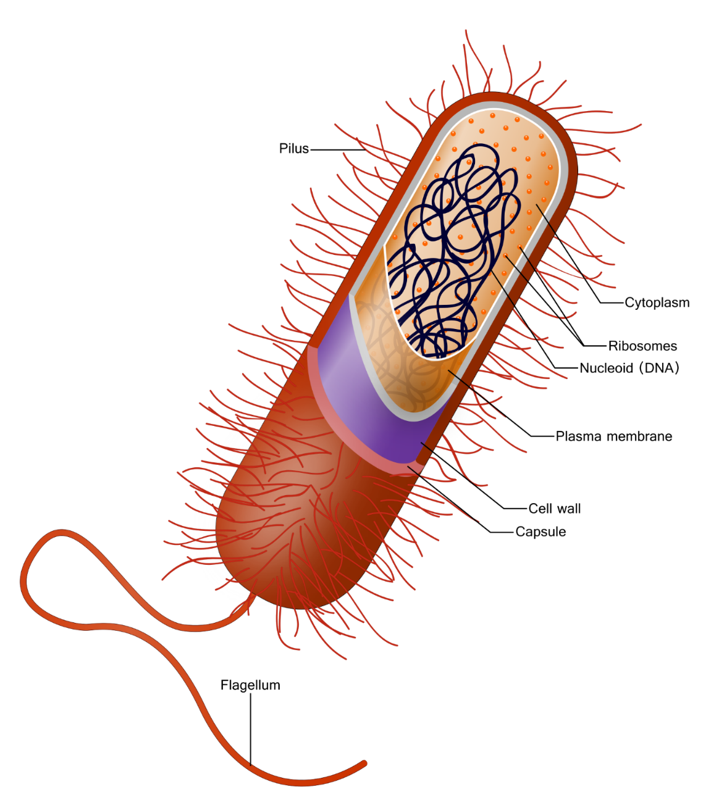

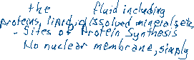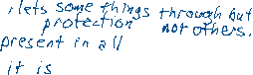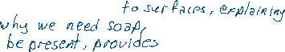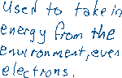

By This vector image is completely made by Ali Zifan - Own work; used information from Biology 10e Textbook (chapter 4, Pg: 63) by: Peter Raven, Kenneth Mason, Jonathan Losos, Susan Singer · McGraw-Hill Education., CC BY-SA 4.0, https://commons.wikimedia.org/w/index.php?curid=44194140