Reduced Cladogram of the Kingdom Animalia (from tolweb.org)
1
5The most notable characteristic shared by ecdysozoans is a three-layered cuticle (four in Tardigrada^{[7]}) composed of organic material, which is periodically molted as the animal grows.
4
2
3

Arthropoda
Onycophora
Tardigrada
Nematoda

Platyhelminthes

Annelida
Mollusca

Ecdysozoa

Lophotrochozoa
Animalia

Choanoflagellates
Bilateria
Myxozoa
Cnidaria
Ctenophora
Placozoa
Porifera
Deuterostomia
Chordata
Echinodermata
Protostomia

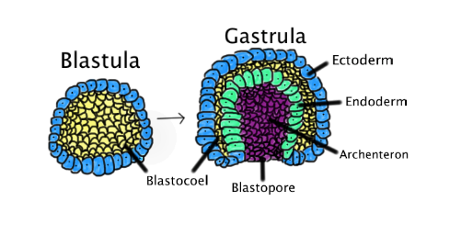
By Abigail Pyne - Own work, Public Domain, https://commons.wikimedia.org/w/index.php?curid=19482001

1. Animals consume organic material, breathe oxygen, are able to move, reproduce sexually, and grow from a hollow sphere of cells, the blastula, during embryonic development.
2. Animals with bilateral symmetry, i.e., they have a head (anterior) and a tail (posterior) as well as a back (dorsal) and a belly (ventral); therefore, they also have a left side and a right side. Bilateral embryos are triploblastic, having three germ layers: endoderm, mesoderm, and ectoderm.
3. In deuterostomes, the first opening (the blastopore) of the gastrula becomes the anus,
4. in protostomes, the blastopore becomes the mouth.
5. The most notable characteristic shared by ecdysozoans is a three-layered cuticle (four in Tardigrada) composed of organic material, which is periodically molted as the animal grows, a process called ecdysis.
(Notes from Wikipedia)

Sample animals of some of the main groups we will study this year:
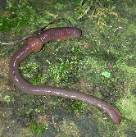
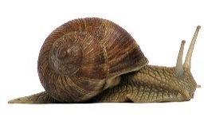
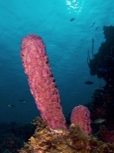
Porifera (Sponges) Cnidaria (Jellyfish) Molluscs (Shellfish) Annelida (Worms)

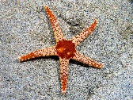
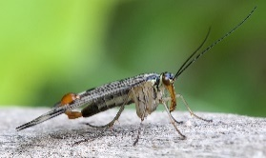
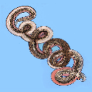
Nematoda (Whip worms) Arthropods Crustaceans, Insects… Echinoderms (Sea stars)

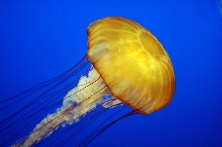
Animal Body Systems
All life has two (2) primary functions:
1.

2.

To perform these two primary functions, life has five (5) secondary functions:
i.

ii.

iii.

iv.

v.

Most large animals have (or had if they are now extinct) eleven (11) body systems to perform the five secondary functions that support the two primary functions. Let’s make the list:

