**Bacteria Now**







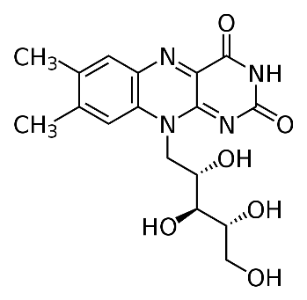**Vitamin B**

Chemical structure of riboflavin.

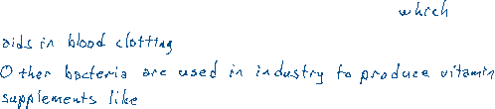

By Calvero. - Selfmade with ChemDraw., Public Domain, https://commons.wikimedia.org/w/index.php?curid=1690365

