Viruses
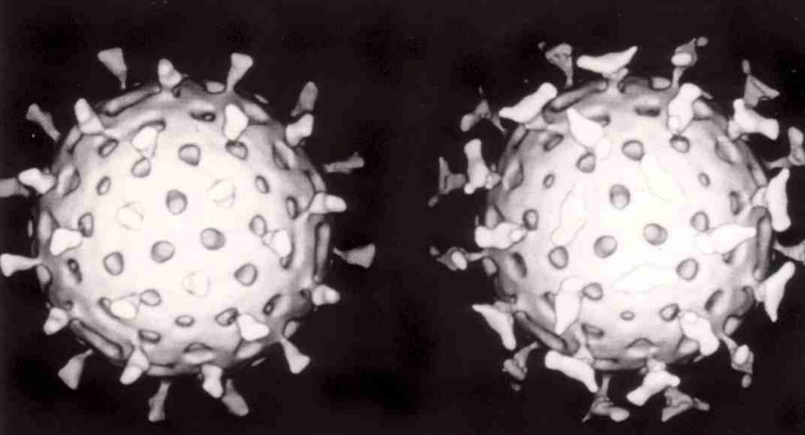
Viruses are small infectious particles composed of a protein sheath containing nucleic acids, either DNA or RNA, that require another organism in order to replicate.
Two rotaviruses, which causes diarrhea: the one on the right is coated with antibodies that prevent its attachment to cells and infecting them.
https://commons.wikimedia.org/wiki/File:Rotavirus_with_antibody.jpg#/media/File:Rotavirus_with_antibody.jpg

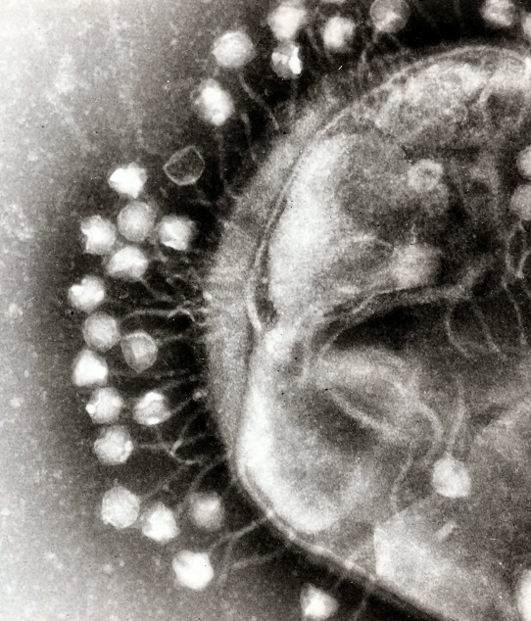
Transmission electron micrograph of multiple bacteriophages attached to a bacterial cell wall.
https://commons.wikimedia.org/wiki/File:Phage.jpg#/media/File:Phage.jpg

T4 Phage – A Bacteria Virus
Copied from http://mintaka.sdsu.edu/faculty/wfw/CLASSES/ASTROBIO/t4.phage
The sinister and eerie T4 phage waits in ambush. When it detects its victim, T4 rotates quickly, pointing its thirty-faceted isosahedral head away from its prey. Now it is ready for the attack.

Attached to its head by a collared neck is T4's tail, consisting of a hollow core surrounded by a contractile sheath. At its base is a spiked end plate from which six fibers emerge.

When its victim draws near, T4 uses its spikes and fibers to grasp onto its prey. Once it has affixed itself, the sheath violently contracts, driving the hollow core into the victim's body. Once the body cavity has been penetrated, it now uses the core as a syringe, injecting the contents of its head into the victim.

After 1 minute: The victim's DNA begins to disintegrate. All production of native proteins cease. Initiation of the production of the alien T4 proteins begins. The first proteins produced then direct the following steps.

After 5 minutes: Replication of T4 phage DNA begins.

After 8 minutes: Initiation of production of structural proteins, which will form the bodies of the new T4 phages.

After 13 minutes: First complete replica of the T4 invader is produced.

After 25 minutes: The final protein is synthesized, lysozyme, which causes the victim to burst open, and 200 identical T4 phages emerge, each fully armed and ready to search out more prey.

The deadly T4 phage neither eats nor sleeps. It is always on the hunt. In some cases, when victim supply is low, it will not produce lysozyme, but rather, lay dormant within the victim's DNA, lurking until the time is right to begin mass production again, even if it means waiting for the prey to reproduce several times. Because the T4 has encoded itself into the victim's DNA sequence, each of the offspring will carry with it copies of T4....
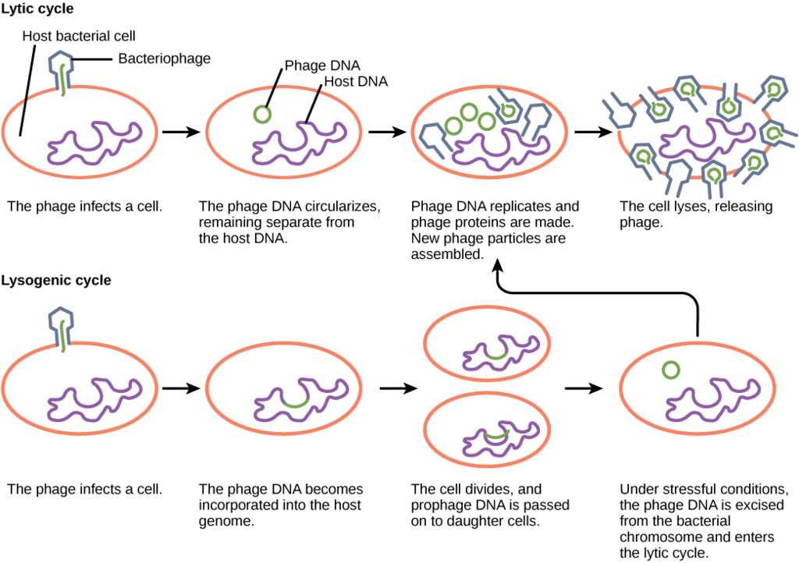

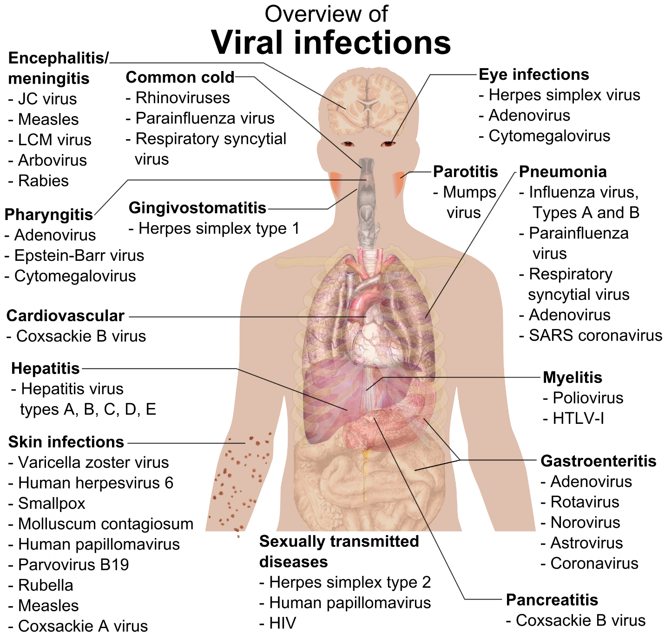
By Mikael Häggström.When using this image in external works, it may be cited as:Häggström, Mikael (2014). "Medical gallery of Mikael Häggström 2014". WikiJournal of Medicine 1 (2). DOI:10.15347/wjm/2014.008. ISSN 2002-4436. Public Domain.orBy Mikael Häggström, used with permission. - All used images are in public domain.ReferencesMainly Chapter 33 (Disease summaries), pages 367-392 in Fisher, Bruce; Harvey, Richard P.; Champe, Pamela C. Lippincott's Illustrated Reviews: Microbiology (Lippincott's Illustrated Reviews Series), Hagerstwon, MD: Lippincott Williams & Wilkins, pp. 367-392 ISBN: 0-7817-8215-5.For common cold: National Institute of Allergy and Infectious Diseases (NIAID) > Common Cold. Last Updated December 10, 2007. Retrieved on 4 April, 2009For exclusion of CMV among the main viral STDs: Lucile Packard Children’s Hospital > Sexually Transmitted Diseases (STDs) Retrieved on 5 April, 2009, Public Domain, https://commons.wikimedia.org/w/index.php?curid=6416098

